Stockbridge

Title of Court
Stockbridge Court Leet & Court Baron

Date of formation  Date of Charter  Lord of the Manor and Borough  Title of Leader of the Court | terminus post quem 1300  terminus post quem 1300  Mr Christopher Robathan  The Lord of the Manor

Offices and Officers of the Court

Steward  Bailiff  Foreman  Sergeant at Mace  Hayward  Jurors | Gavin Burnett  Paul Robinson  Lawrence Stares  Raymond Standfield  John Wrayton  14 Burgesses including the above
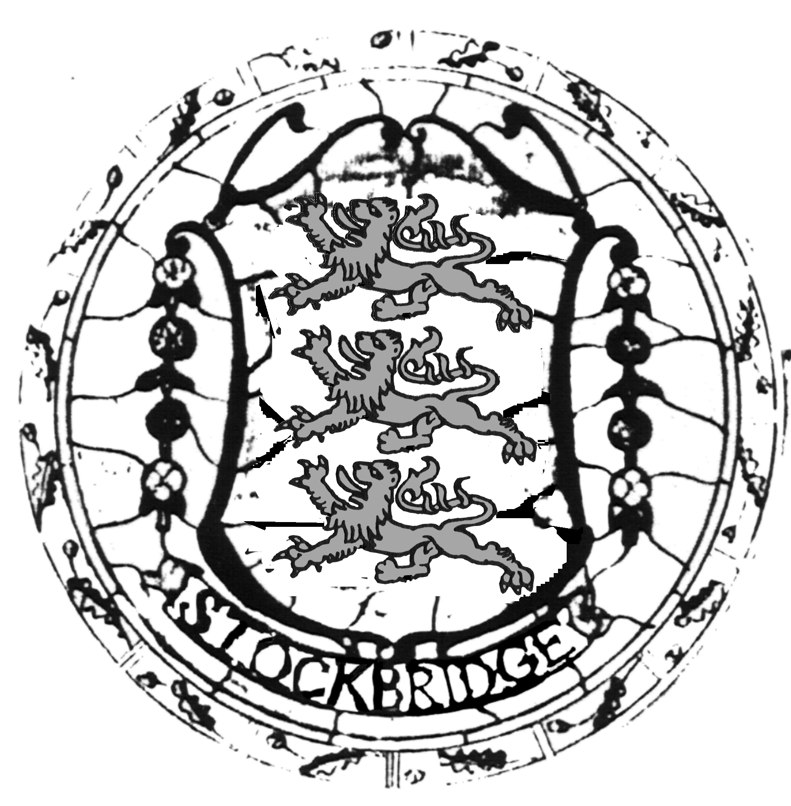
Contact

Paul Robinson
Marsh Meadow
High Street
Stockbridge
Hampshire S020 6ET

Tel: 01264 810609
Brief History

The Court came into being to manage the Common Lands and marches and they still do with the help and co-operation of the National Trust. They fulfil Manorial rights now extinct. They also retain the ancient rights of Burgesses for succeeding generations.

Apart from the Steward, the Bailiff is responsible for co-ordinating business and with the Foreman there are 14 Burgesses who are Jurors assisted by the Sergeant at Mace, now only a titular appointment, and a Hayward responsible for the number of animals grazing Common Lands.

Stockbridge was a Parliamentary Borough until 1832, [as a ‘pocket borough’ in the gift of its Lord] the Bailiff organised the vote for the preferred candidate. The Mace and Seal are not part of the Manor’s regalia but that of the Borough, given as bribes. The Courts were in abeyance from 1891 until 1921 because the then Lord had attempted to seize the Common Down and he lost the subsequent case in the High Court, so that he pawned the Manor to meet his legal expenses. The Courts were restored, with the support of many Burgesses, when Sir Norman Hill became Lord; since then they have been held regularly.

