Ashburton

Title of Court

The Court Leet & The Court Baron

of the Borough of Ashburton

Date of formation  Date of Charter  Lord of the Borough & Manor  Title of Leader of the Court | Circa 1250  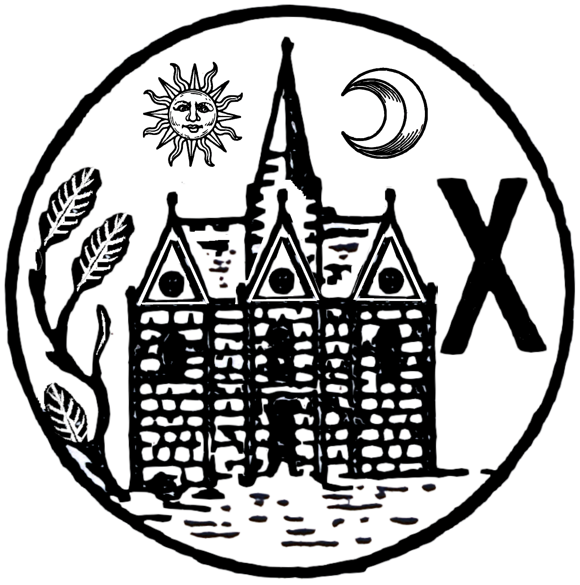  Not advised  Ashburton Town Council  The Portreeve

Offices and Officers of the Court

Portreeve
Steward
Ale Tasters
Bread Weighers

Pig Drovers

Contact

None available

Brief history

Tradition has it that the first Portreeve of the Borough was appointed in the year 820 AD. In the later mediaeval period, and up to the seventeenth century, the Borough of Ashburton and the town of Ashburton were separate entities. The Borough Courts were held in St Lawrence’s Chapel and the town courts separately in the Court House just north of the chapel. At times there were two persons using the name Portreeve in Ashburton, the successor of the Saxon Portreeves in the Borough and the town reeve. In 1394 John Aylmysworth even styled himself “Mayor of the Town”. It is not always possible to tell in old documents whether a person was Portreeve of the Borough or the town official. In the following list of early Portreeves those marked with an * may have been the town officials styling themselves Portreeves:-

Portreeves  Circa 1300 John Ad*  1325 John Toukes*  1335 Robert Michel  1372 Will Taylor  1392 Will Haighewell  1394 Robert Corbet*  1502 John Dobbe | Bailiffs  1281 Richard atte Weye, “Bailiff of the town”.  1392 Will Milleward, “Bailiff of the borough”.  1535 Richard Mercer, “Bailiff of Ashburton Foreign”.  1618 Richard Oliver who had been “Bailiff” and  Thomas Dabernon who had been “Bailiff of the Liberty”  were both living in Ashburton
.

From 1747 the list of Portreeves is complete except for the seven years between 1754 and 1760 and the twenty-five years between 1806 and 1830. The names of Portreeves since 1900 are displayed on a board in the Chapel of Saint Lawrence.

The Court Leet & The Court Baron

(Notes prepared by C. Gamble, Esq., MA, Portreeve of Ashburton for the year 1960-1961; the 1,140th Portreeve. These have been amended where necessary in accordance with the 1976 Rules for the Leet and Baron Juries of the Borough of Aysheberton) Both Courts are Borough Courts. The Manor Courts have not met in Ashburton since 1908. As Borough Courts their deliberations are only valid if they sit within the old Borough. Both the Chapel of St Lawrence and the Golden Lion were within the old Borough, but the Town Hall was not as it was within the Manor.

The distinction between freeholders on the Leet Jury and tenants on the Baron is essential to the existence of these Courts. Without such a distinction they become just a collection of residents and lose all their rights. If a member of the Leet Jury should sell his freehold he is no longer eligible for the Leet Jury. If he should then obtain a tenancy he becomes eligible for election to the Baron Jury. In the last century several Leet Jurors became Baron Jurors in this way. Rule 2 of the 1976 Rules permits those who work in Ashburton to be members of the Baron Jury.

The only qualifications, apart from the property ones, required of jurors in either court are that they shall not be clergymen of the Church of England and that they shall have been resident for at least one year. (“Leet Jurisdiction”. Selden Soc. vol 5 BM-AC2176. p. xxvii.) (Amended in the 1976 Rules to three years’ residence.)
The Leet Jury are entitled to elect the Bailiff, Ale Tasters and Bread-weighers who need not be members of the juries or even residents (except the Bailiff who must be a resident). The Baron Jury are entitled to elect the other officers such as pigdrovers, etc, on the same qualifications.
The Portreeve can only be elected by a properly constituted Court Leet. (Halsbury Laws of England, v.8, p.765.) This also applies to the Bailiff. When, in Ashburton in 1833, an improper election took place the Crown intervened and the costs against those improperly electing amounted to over £3,000 [R v Woodley]. The Portreeve can be a member of either jury or of no jury and non-residents have been elected in the past (affidavits in R v Woodley). The ownership of the Portreeve’s and Bailiff’s chains is vested in the Court Leet and only it can loan them to these Officers for the period of their office. Though the Court Leet is a Queen’s Court (Halsbury, Laws of England) as well as a Borough Court and the Court Baron is a Borough Court only there is no superiority in function of one over the other and they have equal powers of making ‘presentments’. The mediaeval meaning of ‘a presentment’ is “A statement on oath by a jury of a fact within their knowledge” (SOED). There is no suggestion of presenting something to someone. The juries can make a presentment of anything within their knowledge. The only limitation on this is that laid down in the case of Wood v Lovett (6 Term Rep. 511) where it is stated that such a court can present its Lord of a Borough for a public act but not for a private act (for which resort must be had to the ordinary courts). When the Lord of a Borough is a public body all its acts are public.

The Lord of the Borough of Ashburton

(Extract from the 1976 Rules for the Leet and Baron Juries of the Borough of Ayshberton in the County of Devon, as presented at the Court Leet and Law Day of our Sovereign Lady the Queen, and at the Court Baron of the Ashburton Town Council, Lord of the said Borough, in the Chapel of St Lawrence on the twenty third day of November 1976).

The title “Lord of the Borough of Ashburton” passed from father to son like any other property, at some periods it was shared between families and then reference was made to the “Lords of the Borough”. In 1927 the title passed from the last private individual to the Ashburton Urban District Council, which had been formed in 1898, and this council became Lord of the Borough as a corporate body. It also became owner of the Town Hall and “Lord of the Manor” at the same time.

In 1974 the ownership of the Town Hall was transferred to Teignbridge District Council and the newly formed Ashburton Town Council became “Lord of the Borough of Ashburton” and “Lord of the Manor of Ashburton”. The present Court of the Leet and Baron Juries is a Borough Court, the Manor Court has not met since 1908, thus members of the Leet and Baron Juries should refer to the “Lord of the Borough of Ashburton”.

It is incorrect for the Town Council to be referred to as “Lords of the Borough” as the word “Lords” implies that individual councillors are Lords of the Borough. It is also incorrect to consider that the Town Mayor is the “Lord of the Borough”. The Town Council holds the title in a corporate sense, and it is in that capacity that it appoints a Steward to conduct all Court proceedings and assumes responsibility for ensuring that the presentments made by the Juries are passed on to the correct authority.

It has been the custom in Ashburton for the Lord of the Borough to be present at the Annual Court and Law Day and to open and close the proceedings. This is held at the Chapel of St. Lawrence, Ashburton on the fourth Tuesday in November at 4 pm. Since the transference of the title in 1927 to a corporate body it has been customary for that body to be represented by one of their number. Normally the Town Council would appoint the Town Mayor as their Representative, but they are free to appoint who they choose. For example, in the event of the Town Mayor being required to be present at the Annual Court and Law Day in some other capacity, or should he be indisposed they might well elect to be represented by a senior member of one of the Juries.

The Lords of the Manor and Borough of Ashburton from before 1050
????-1050 Bishops of Crediton
1050-1549 Bishops of Exeter
1549-1552 Francis Pole, then John Beaumont
1552-1630 The Crown and its nominees

Joint Lords of the Manor and Borough from 1630 to 1906

1630-1651 Sir Robert Parkhurst  1651-1666 Sir Robert Parkhurst  1666-1669 Sir John Stawell  1669-1702 William Stawell  1702-1704 Christopher Ball  1704-1739 Roger Tuckfield  1739-1754 Hon John Harris in right  of his wife, Margaret Tuckfield  1754-1781 Margaret, Countess of Orford  1781-1791 George, 3rd Earl of Orford  1791-1797 Robert George William Trefusis,  from 1794 17th Baron Clinton  1797-1832 18th Baron Clinton  1832-1866 19th Baron Clinton  1866-1904 20th Baron Clinton  1904-1905 21st Baron Clinton  1905-1906 Hon Richard Maitland Westenra  Dawson | 1630-1633 Ralph Freeman  1633-1677 Sir George Sondes (1st Earl  of Feversham)  1677-1681 Hon Lewis Watson in right  of his wife, Lady Catharine Sondes  1681-1716 Richard Duke, Sen.  1716-1724 Richard Duke, Jun.  1724-1755 Sir William Yonge, 4th Bart  1755-1773 John. Duke  1773-1798 Sir Robert Palk, 1st Bart,  lessee until 1788-1789  1798-1813 Sir Lawrence Palk, 3rd Bart  1813-1845 Sir Lawrence Vaughan Palk, Bart  1845-1864 Sir James Matheson, 1st Bart  1864-1905 Sir Robert Jardine, 1st Bart  1905-1906 Sir Robert Buchanan Jardine,  2nd Bart

Lord of the Manor and Borough from 1906

1906-1914 Hon Richard Maitland Westenra  Dawson  1914-1915 Jane Emily Dawson  1915-1926 Henry Mallaby Firth | 1926-1927 Ralph Woodley Woodley  1927-1927 Harriett Hilda Woodley  1927-1974 Ashburton Urban District Council  1974- To date Ashburton Town Council

